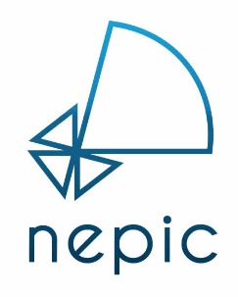
Asset Management Conference 2022
8th February 2023 – Hardwick Hall Hotel

SPEAKER SLOT - EXPRESSION OF INTEREST FORM
If you are interested in presenting at our Asset Management, please fill out this expression of interest form.
The intention of this form is to create a pipeline of talks in order to allow the NEPIC team to construct conference agendas. Please note, submission of an EOI does not guarantee a speaking slot as we have limited availability.

Talks should last around 15 minutes with 5 minutes set aside for questions (20 minutes in total).

Relevant themes include the below, but please do propose a talk which you feel has relevance to the wide themes of asset management, manufacturing improvement and productivity:
- Plant Reliability
- Energy and Resource Management
- Process Safety
- Productivity (OEE)

Conference

Asset Management Conference 2023

General Information

Name:
Job Title:
Company:
Website URL:

Presentation Title

Abstract (max 250 words)

