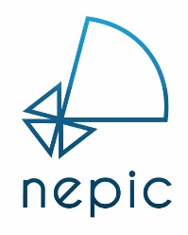

MEMBERSHIP APPLICATION FORM

Many thanks for your interest in becoming a NEPIC member. So that we can get things moving as quickly as possible for you, can we please ask that you complete the below form
and return to ebba.mcguigan@nepic.co.uk.
Once we receive your application, we will be in contact to discuss your company, your aspirations for your membership and how we can help you succeed within the sector.
We look forward to welcoming you to the cluster.

ABOUT YOUR BUSINESS
Company Name
Address
Web Address
Company E-mail

MEMBERSHIP PRIMARY CONTACT
Name
Job Title
E-mail
Telephone No.
Mobile No.

MEMBERSHIP CATEGORY
Category | Number of  UK Employees | Annual Pro-rata  Fee (ex VAT) | Please
Micro | 1 – 2 & start-ups & not-for-profits | £225
Mini | 2 - 10 | £300
Small | 11- 50 | £525
Medium | 51 - 250 | £825
Large | 251 + | £1,275
Group | Group – Multiple Companies | £1,950
Partners | Associations & Academic | £375

What aspect of our services would you like to know more about?
How did you hear about NEPIC?
Date
For internal use only | Membership Number

