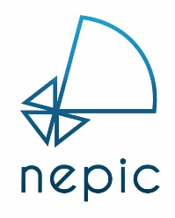

MEMBERSHIP APPLICATION FORM

Many thanks for your interest in becoming a NEPIC member. So that we can get things moving as quickly as possible for you, can we please ask that you complete the below form and return to ebba.mcguiguan@nepic.co.uk.
Once we receive your application, we will be in contact to discuss your company, your aspirations for your membership and how we can help you succeed within the sector.
We look forward to welcoming you to the cluster.

ABOUT YOUR BUSINESS
Company Name
Address
Web Address
Company Email

YOUR DETAILS
Name
Job Title
Email
Telephone No.
Mobile No.

MEMBERSHIP CATEGORY* (please select)
Category | Number of UK Employees | Annual Fee (ex VAT) | Please
Micro | 1 – 2 & start-ups & not-for-profits | £300
Mini | 2 - 10 | £400
Small | 11- 50 | £700
Medium | 51 - 250 | £1,100
Large | 251 + | £1,300
Group | Group – Multiple companies | £2,600
Partners | Associations & Academic | £500

Signature
Purchase Order No.
Date
For internal use only | Membership Number

